**What is Linear Search?**

A Linear Search is the most basic type of searching algorithm. A Linear Search sequentially moves through your collection (or data structure) looking for a matching value. In other words, it looks down a list, one item at a time, without jumping. **Thus a linear search is a sequential search algorithm that utilizes the concept of comparisons to get data in a list.**

Think of it as a way of finding your way in a phonebook. A Linear Search is starting at the beginning, reading every name until you find what you’re looking for n complexity terms this is an O(n) search - the time taken to search the list, gets bigger at the same rate as the list does.

Here is an image of Linear Search: Suppose we want to search for element 5. We start comparing elements from the first index (from beginning). If it does not match, we move on to the second elements. The process continues a match is found. If the element is not in the list, then the comparisons goes on up to the end of the list and then stops if there are no more elements to be compared. In that case we indicate the element is not found. In this example we start comparing 5 with will be found at index 6 and the search stops. Note sometime we allow search to continue in case we want to find whether there is a recurrence of the data. For that matter, search goes on until the end of the list.

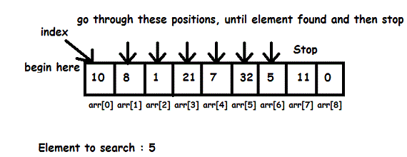

**Linear Search: Steps on how it works:**

Here is simple approach is to do Linear Search:

* Start from the leftmost element of array and one by one compare the element we are searching for with each element of the array.
* If there is a match between the element we are searching for and an element of the array, return the index.
* If there is no match between the element we are searching for and an element of the array, return -1.

**Comparison between Binary Search and Linear Search:**

* Binary Search requires the input data to be sorted; Linear Search doesn’t
* Binary Search requires an *ordering* comparison; Linear Search only requires equality comparisons
* Binary Search has complexity O(log n); Linear search has complexity O(n)
* Binary Search requires random access to the data; Linear Search only requires sequential access (this can be very important — it means a Linear Search can *stream* data of arbitrary size)

Overall Linear Search is an important concept to understand when it comes to algorithms. Also is important to compare it with other algorithms like Binary Search to see when it is an advantage or disadvantage to use Linear Search.

**Algorithms for Linear Searcb**

**int linearsearch(int arr[], int n, int num)**

**{**

**for(int i=0;i<n;i++){**

**if(arr[i]==num)**

**return i;**

**}**

**// Item not found in the array**

**return -1;**

**}**